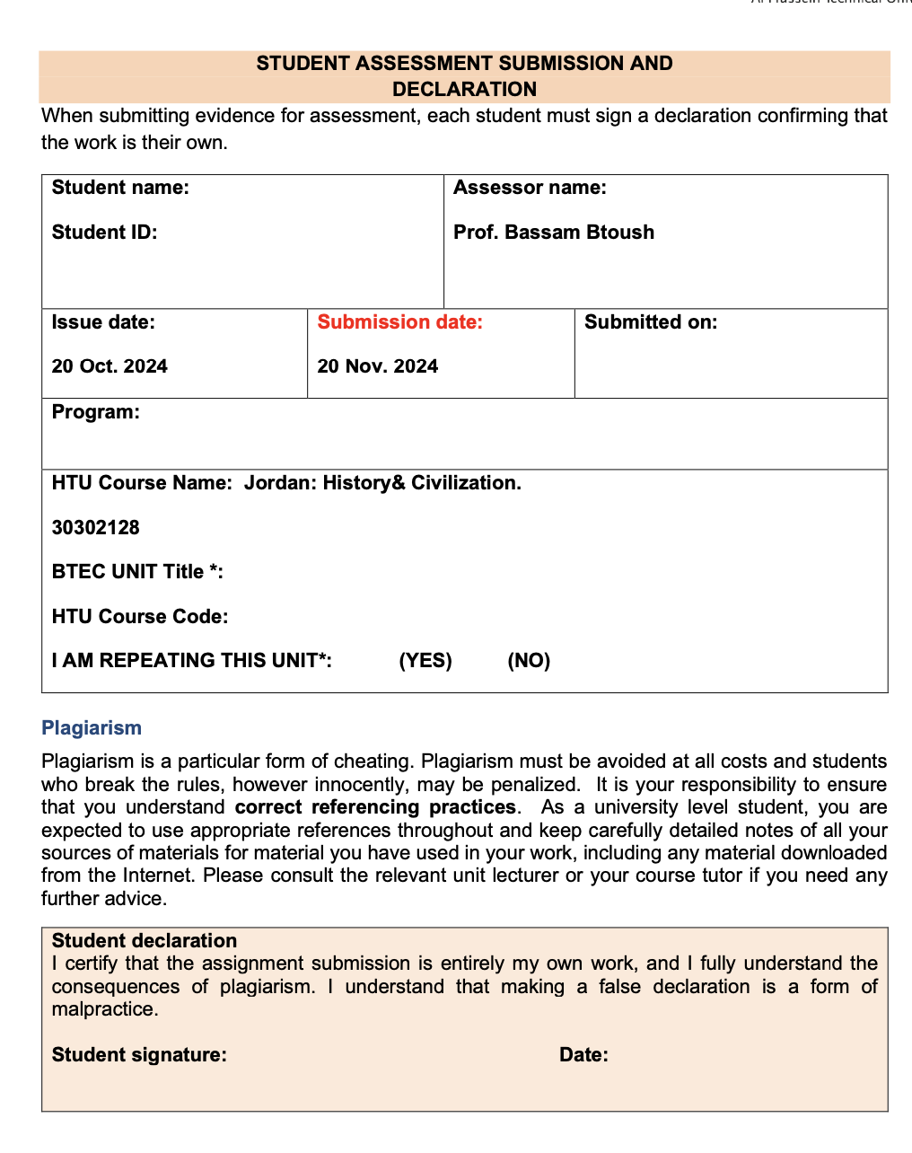

23/11/2024

Saif haddad



Saif haddad

21110214